DON’T BE MISLED BY THE FINE PRINT IN THE SCHOOLS BILL
What Does It Really Mean for Our Hershele?

A VERY GOOD QUESTION — AND ONE EVERY PARENT MUST ASK.
This isn’t just another piece of legislation. Behind the polished language lies a direct threat to the way we raise and educate our children, in accordance with Torah values and Mesorah.

LET’S SPELL IT OUT:
According to official government documents:
- Our sons may be forced to learn about lifestyles and ideologies that go against everything we believe in — including explicit content and to’eivah teachings that are entirely inappropriate in a Torah-true chinuch.
- Time for Limud HaTorah will be slashed — replaced with ‘suitable education’ that prioritises secular studies and ideological conformity over Torah and Yiras Shomayim.
- Home education will no longer be private — council inspectors will have the right to enter homes, interrogate parents, and scrutinise what is being taught. Chinuch will be subject to state approval.
- Yeshivos that uphold Torah standards but do not follow the official curriculum face closure — institutions built with mesirus nefesh may be shuttered for teaching Torah al derech hamesorah.

GEDOLEI YISROEL SPEAK OUT:
- Harav Avrohom Gurwitz שליט"א warned:
"If this bill passes, we may need to educate our children outside the UK."
- Leading Roshei Yeshiva from the UK and Lakewood have signed powerful letters, calling it a “sacred obligation” to daven and take action.

STAND UP FOR THE FUTURE OF TORAH CHINUCH — SIGN THE DECLARATION TODAY.
Research into the background of the new Schools Bill, and a careful review of its disturbing proposals, make it unmistakably clear:
This Bill is not accidental. It is the product of years of concentrated effort by extreme leftist and secular forces — those who oppose Torah and traditional values with all their strength.
Through sophisticated strategies and gradual legislation, they are seeking to impose their worldview upon us — aiming to reshape the very future of Klal Yisroel by influencing how our children are raised, think, and believe.
This is not about improving education. It is about undermining religious life, family values, and the core foundations of our heritage.
They move slowly, cleverly, and methodically — planting seeds of secularisation, infiltrating through conditional funding, regulatory demands, and full legal backing.
Their goal is clear: to force Yeshivos, schools, and families to conform to a system that has no place for Torah or Mesorah.
They are patient, calculating, and powerful — but we, too, have the greatest strength:
Tefillah, Emunah, and Action.

WE MUST NOT STAY SILENT. WE MUST NOT STAY STILL.
It’s time to stand up — with clarity, with unity, and with firm resolve.
Because when it comes to our Hershele, compromise is not an option.

📜 THE CALL TO ACTION
Every Signature Counts. Every Voice Matters.
Every Jewish adult bears this responsibility.
This is not just a “school matter.”
This is not for askanim alone.
This is about your children. Your grandchildren. Your eternity.

WHAT CAN YOU DO?
SIGN THE DECLARATION OF OPPOSITION.
Under the guidance of Rabbonim, a unified declaration has been prepared.
This declaration expresses, with respect and unity, the deeply held convictions of our community:
- Compliance with such a law is impossible for us — like asking a fish to live outside water. It strikes at the very essence of who we are.
- We can never surrender control of our children’s chinuch.
- We cannot and will not remain silent.
This is not a petition.
It is a sacred statement of identity.
With Hashem’s help, every signature becomes a powerful act of conviction — a stand for eternal truth.

LET OUR NUMBERS ROAR WITH EMUNAH:
- Add your name.
- Share it with others.
- Speak about it at your table.
- Teach your children why we fight — and what we stand for.
History has taught us: whenever we are tested, it is those who stand up for the Torah who safeguard the future.

THIS IS OUR MOMENT. THE TEST IS UPON US. WE CANNOT STAND SILENT.
בְּשֵׁם ד׳ נַעֲשֶׂה וְנַצְלִיחַ

ACT NOW — THE DEADLINE IS DRAWING CLOSE!
Take your place among the defenders of Torah chinuch.
In a generation tested by silence, it is those who speak who help bring salvation.
Make your voice heard.

GET THE FACTS IN UNDER 20 MINUTES:
Call our recorded hotline: 0330 909 0265
Or listen online by scanning the QR code:
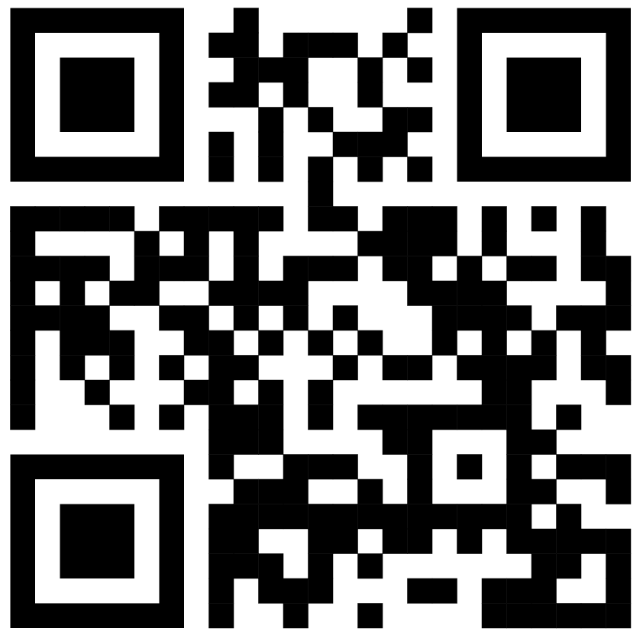
HOW TO SIGN:
- 📜 Declare your opposition to government interference in Jewish education by signing the declaration form. Scan the QR code below:
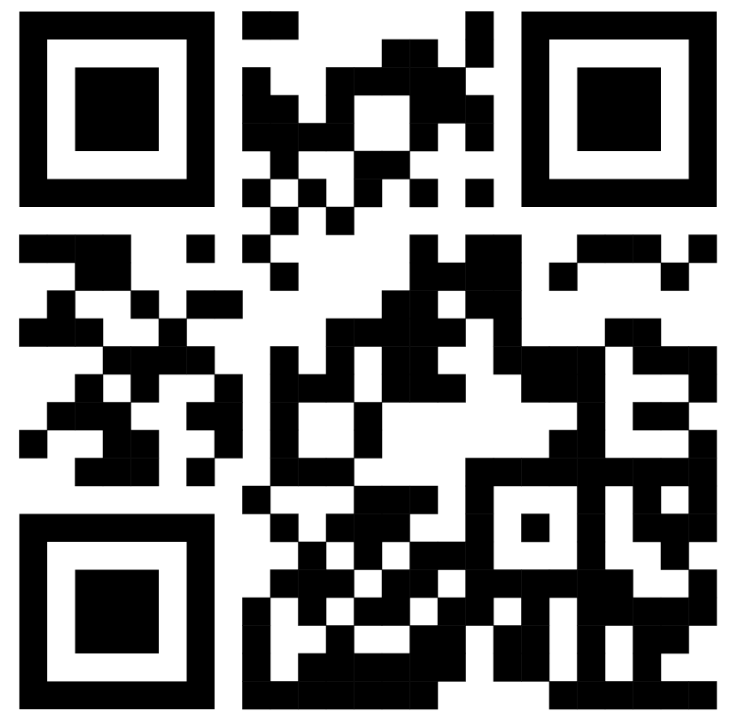
Or text “I AGREE” to 07463 066 613.
- 📖 To read all factual information, scan the QR code.
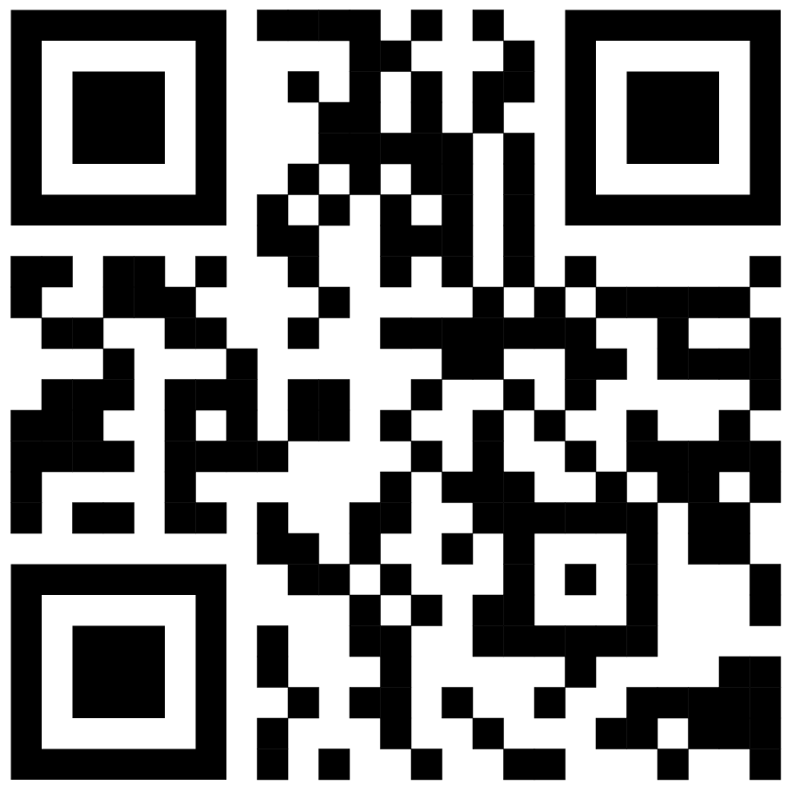

Forward this message to 5 people — help spread awareness!
Want to help others sign? Call/Text: 07743 022 676
Declaration of Parental Rights and Educational Freedom
To the Department for Education:
To the Department for Education and Members of Parliament and the House of Lords:
I affirm my unwavering belief that every parent - regardless of background - holds the inalienable right and the primary responsibility to guide the moral, religious, and educational upbringing of their children, in accordance with their conscience, values, and cultural or faith-based beliefs. Any attempt by the state to override this sacred duty constitutes a profound infringement on religious liberty, parental autonomy, and the very foundations of family life in this country.
If enacted in its current form, Clauses 30 - 35, and 36 - 42 of the Children’s Wellbeing and Schools Bill would grant the state sweeping powers that are excessive, intrusive, and without proper justification. These provisions would impose burdensome registration, surveillance, and compliance requirements on parents and educational institutions. They would empower local authorities to monitor, interrogate, and potentially override the educational choices of families - even where there is no evidence of harm or neglect.
As a UK resident, and a committed supporter of family and educational freedoms, I am deeply troubled that this Bill disregards the flexible, values-based nature of faith and independent education. It imposes uniform secular standards that are incompatible with many religious traditions, and risks criminalising parents or educators who cannot, in good conscience, conform. In doing so, the Bill poses a direct threat to the freedom of families to raise children in accordance with their deeply held beliefs - a responsibility I consider a matter not only of conscience, but of moral and spiritual obligation.
The proposed legislation also contravenes several fundamental rights under the Human Rights Act 1998: Article 8, which protects the right to private and family life; Article 9, which protects freedom of religion and belief and Article 2 of Protocol 1, which obliges the state to respect parents’ rights in education. In addition, the Bill raises serious concerns under UK Data Protection law, permitting the intrusive collection and monitoring of sensitive educational and personal data without adequate justification or safeguards.
It also violates core principles of British constitutional law, including proportionality, restraint in state interference, and respect for the home as a protected sphere. By enabling state officials to overrule parental judgement and faith-based education - without clear limits, due process, or adequate safeguards - the Bill risks replacing trusted civic partnerships with coercive bureaucratic overreach.
I am a committed and law-abiding citizen who respects the rule of law and democratic institutions. However, when the legislative process produces measures that threaten the liberty and dignity of family life, conscience demands that I raise my voice. I therefore declare my principled and respectful opposition to this Bill in its current form. It is with a heavy heart that I say: if this Bill becomes law as drafted, I do not see how, in good conscience, I could comply with its demands. This is not a matter of personal convenience. It is a matter of identity - of who we are, and who we have the right to be as parents and people of faith. No community can survive without the ability to pass on its values and beliefs to the next generation.
I therefore urge His Majesty’s Government and Parliament to amend this Bill. As currently drafted, it undermines the long-established principle in British constitutional and common law that parents - not the state - bear primary responsibility for the moral and educational upbringing of their children. No democratic legislature can enact measures that violate this foundational tenet without risking serious conflict with the principles of proportionality, legitimate aim, and respect for private and family life, upon which its legal authority is contingent.
Full Name | Email address or Postal Address | Postcode | Signature
Please return the completed form to 2 Filey Avenue, London N16 6NT; 134 Craven Park Road, London N15 6AB
or 32 Whitehall Road, Gateshead NE8 4ES.

